**Scope Document for Library Management System**

**Project: Develop Library Management System for Hanoi University**

**Development Company:** ABC Company  
**Client:** Hanoi University

**I. Scope Statements**

A service agreement was established between ABC Development Company (as the service provider) and Hanoi University (as the client) in September 2022. Both parties aim to develop and deliver a software system, a Library Management System, to be used as an online library service for Hanoi University. The system includes three modules:

1. **Sub-system 1: Building a Central Database for the Library.**  
   A Central Database will serve as the backbone of the Library Management System, storing all relevant data regarding books, users, reservations, and transactions, ensuring data integrity and accessibility.
2. **Sub-system 2: Develop a Search and Reserve Service for all university students and lecturers/staff.**  
   This service enables users to search for available books, view their details, and reserve them for borrowing, enhancing the user experience and streamlining the borrowing process.
3. **Sub-system 3: Develop a Book Management Sub-system.**  
   This sub-system will facilitate the management of book inventories, including adding, updating, and deleting book records, as well as tracking their availability status.

**A. Overall Objectives:**

* O1: Provide a comprehensive library management tool for efficient book tracking and management.
* O2: Enhance user experience through an intuitive interface for searching and reserving books.
* O3: Ensure data security and integrity through a robust central database.
* O4: Deliver training sessions for university staff to effectively use the system.

**B. Justifications:**

Hanoi University chose ABC Development Company for its proven track record in delivering high-quality software solutions tailored to educational institutions. The benefits to the client include:

* A user-friendly system that improves library access and efficiency.
* Reliable technical support and maintenance services post-deployment.
* Customizable features to adapt to future needs of the university

**II. Deliverables**

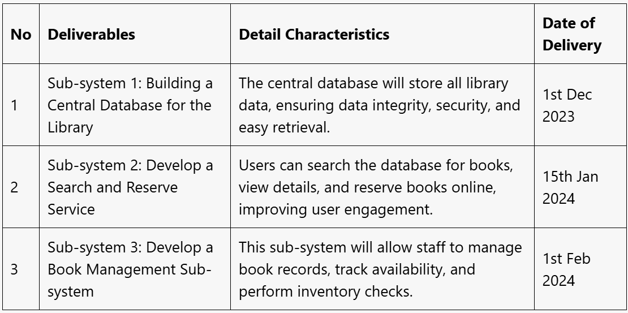

**III. Work Breakdown Structure (WBS)**

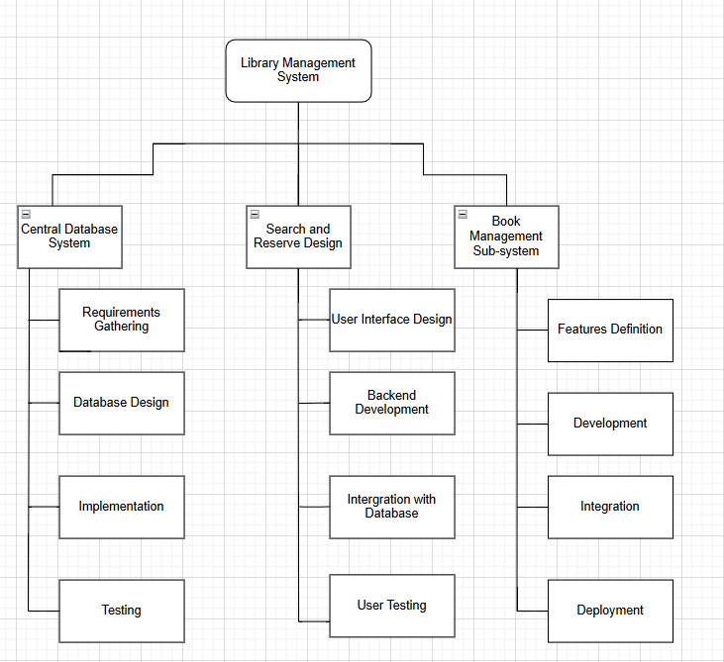

**WBS & Development estimated effort**

